1. **Agenda**: <https://github.com/in28minutes/MockitoTutorialForBeginners/blob/master/Step04.md>
   1. 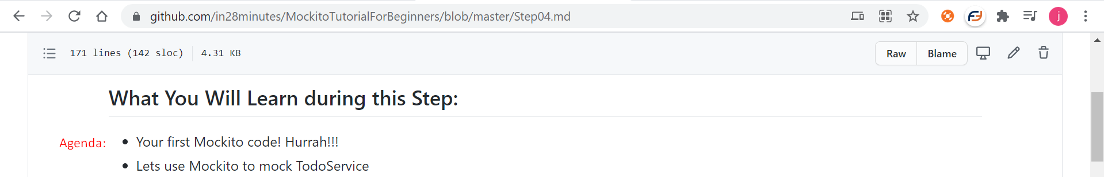
2. 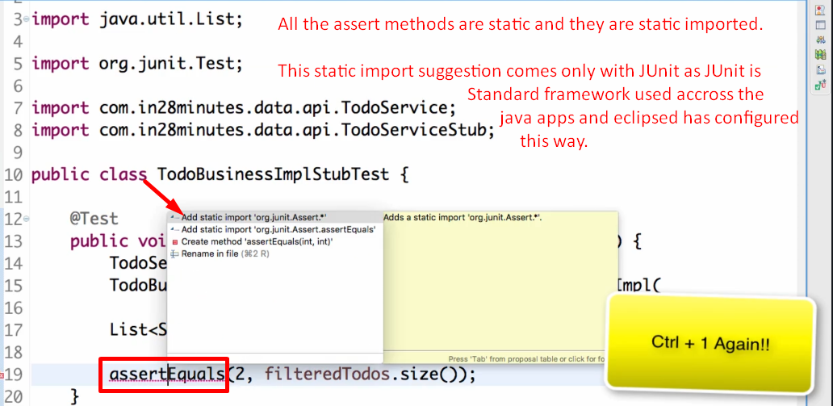
3. 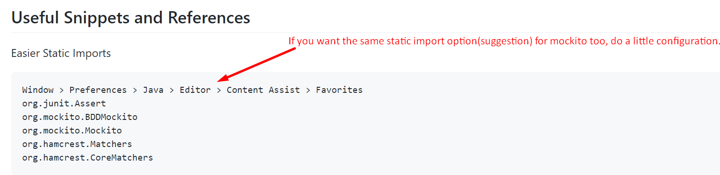

**NOTE**: org.junit.Assert is already configured as static import by eclipse.

1. 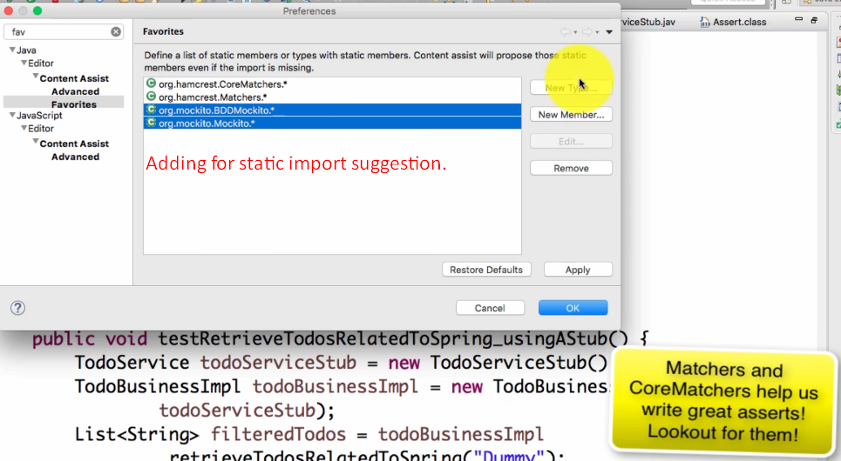
2. 
3. 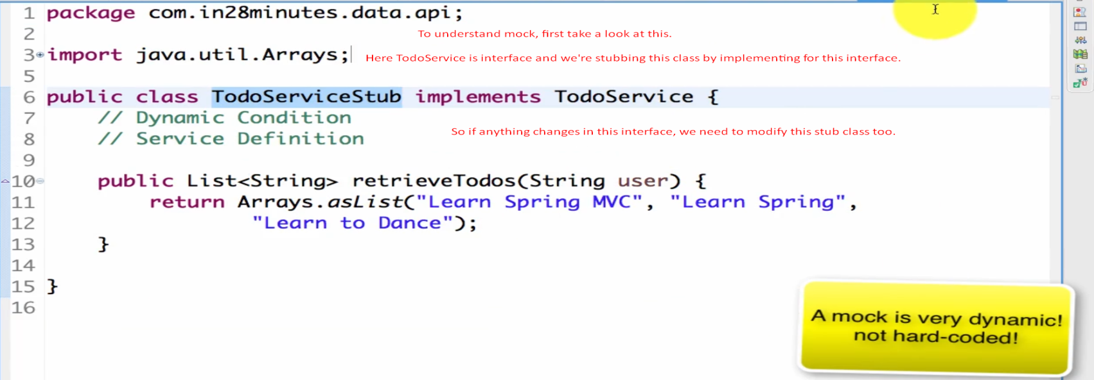
4. 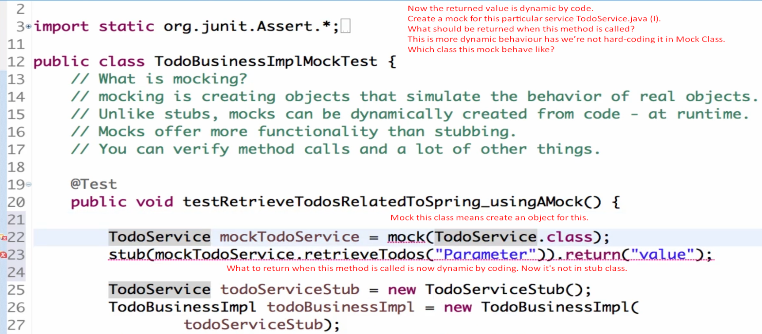
5. There are frameworks which allow you to do such kinds of things and this is what is **called** **Mocking.**
6. Let’s try to write mockito code.  
   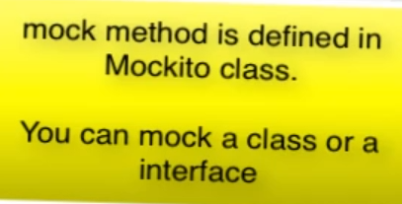
7. 
8. 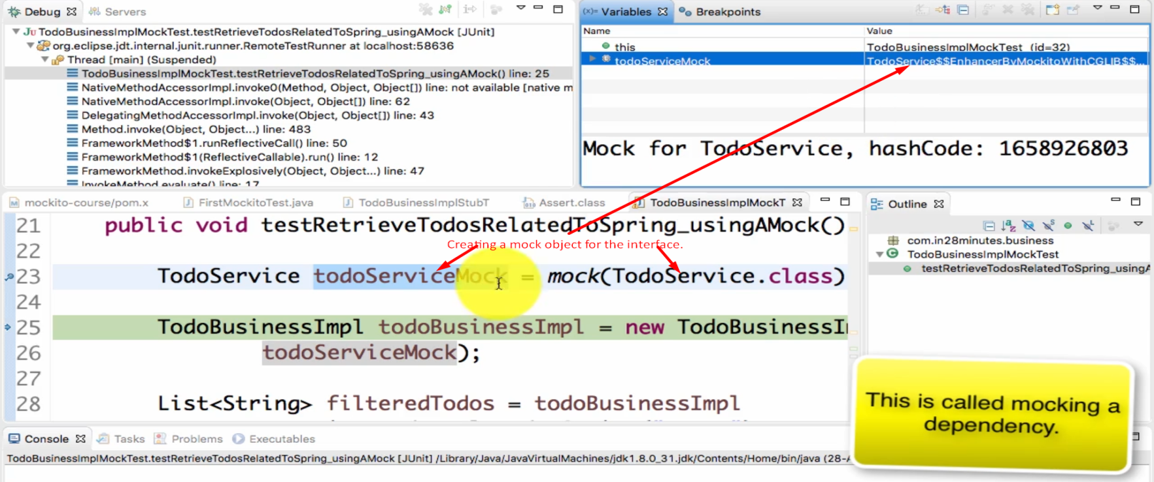
9. 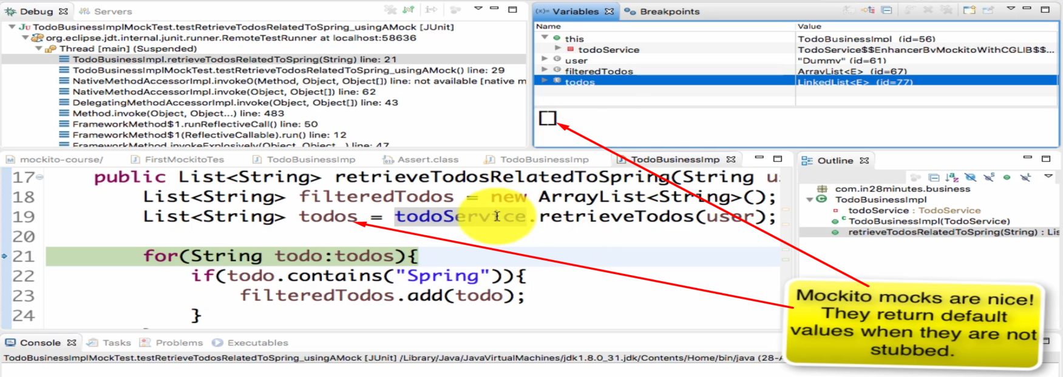
10. 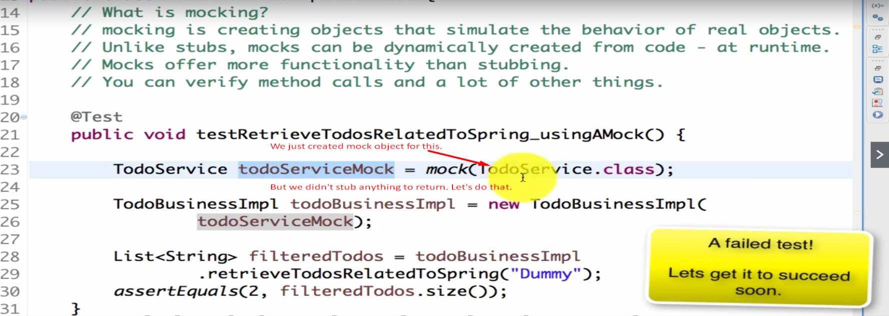
11. 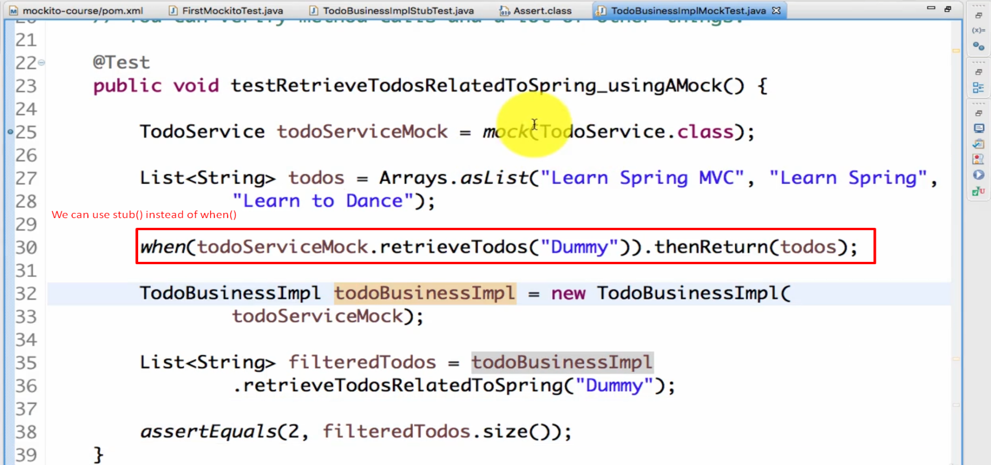

**Advantages:**

1. No need to implement interface just call mock(InterfaceName.class) which would return mock object for that interface.
2. Now for different cases we can code to return different kinds of dummy data by calling **when**(mockObject.method()).**thenReturn**(value);

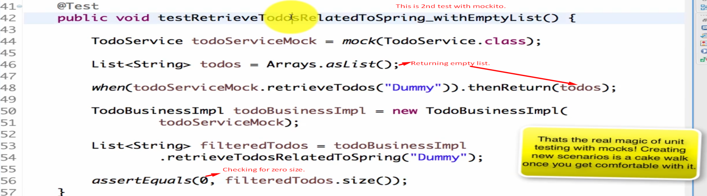

<https://github.com/in28minutes/MockitoTutorialForBeginners>